**Lab 2 Deliverables**

**for**

**Team Arceus**

**Version 1.0 approved**

Prepared by

KENNETH GOH JING WEI

LAU SHAO WEI

LEE DING ZHENG

JADHAV CHAITANYA DHANANJAY

JAVIER NEOH HONG RUI



**23/2/2023**

Lab 2 Deliverables

1. Project idea
   1. Calorie tracker and recipe recommendation application

The application will provide recipe recommendations based on the daily calorie and protein goals of the User.

1. Target Audience
   1. Users who want a quick and easy way of monitoring their daily nutrition intake.
   2. Users who want different and healthy meals everyday.
2. Use-Case Diagram

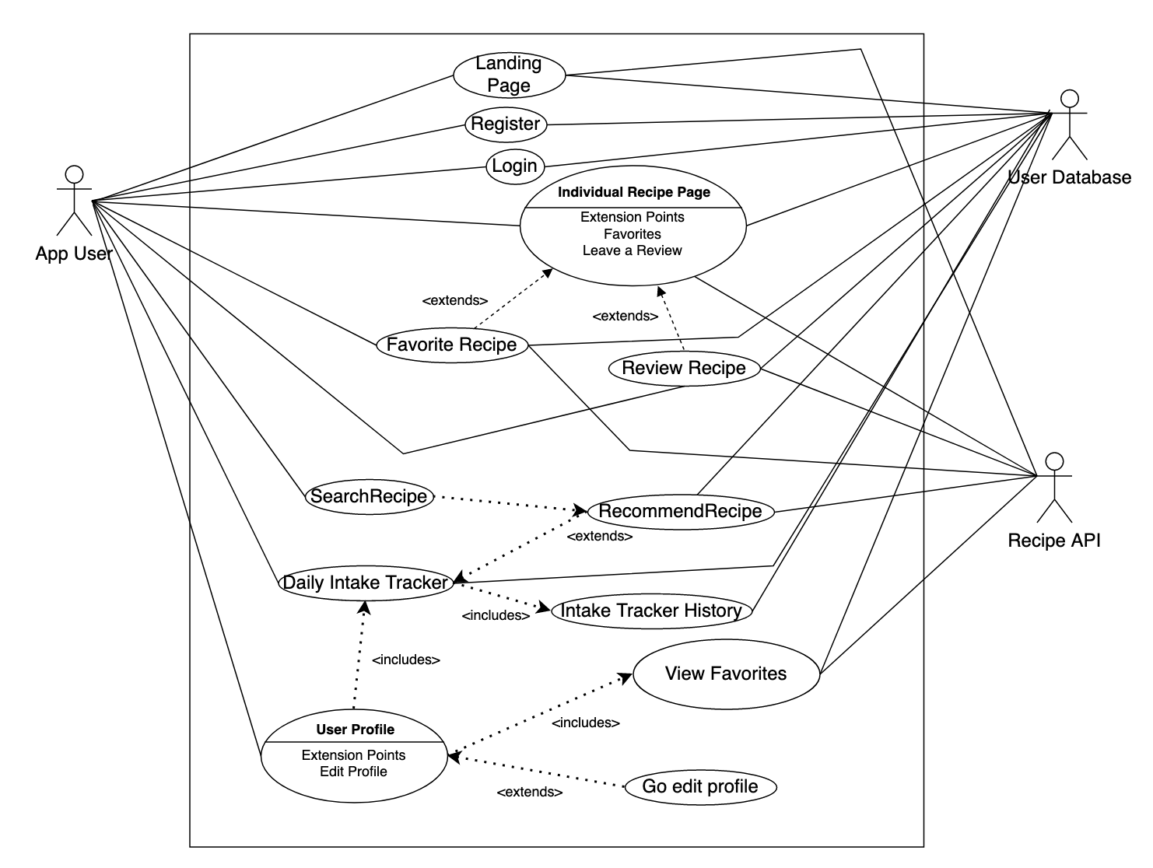

1. Functional Requirements and Use Case Descriptions
   1. **Landing Page**

| Use Case ID: | 001 | | |
| --- | --- | --- | --- |
| Use Case Name: | Landing Page | | |
| Created By: | Jadhav Chaitanya Dhananjay | Last Updated By: | Jadhav Chaitanya Dhananjay |
| Date Created: | 04/02/2023 | Date Last Updated: | 04/02/2023 |

| Actor: | User |
| --- | --- |
| Description: | Guest User accesses the website and is by default directed to this page. |
| Preconditions: | The User is not logged in to their account. |
| Postconditions: | The application shows the User the highest average rated recipes. |
| Priority: | Medium |
| Frequency of Use: | Medium |
| Flow of Events: | 1. User navigates to the home page of the application. 2. Application retrieves the highest average rated Recipes from the database. 3. Application displays the top 5 average rated Recipes with Recipe Information and presents it to the User. 4. Recipe information includes recipe name, average rating and nutritional content. |
| Alternative Flows: | NIL |
| Exceptions: | NIL |
| Includes: | NIL |
| Special Requirements: | NIL |
| Assumptions: | 1. The User must be connected to the internet when accessing the application. |
| Notes and Issues: | NIL |

* + 1. All Users must be navigated to the Landing Page during the first time they access the application.
    2. The application must display recipe cards of the top 5 average rated recipes on the Landing Page.
       1. Recipe cards must contain the Name of the recipe.
       2. Recipe cards must contain the Key Nutritional Facts of the recipe.
       3. Recipe cards must contain the Average User Rating of the recipe.
       4. Recipe cards must be ordered in terms of decreasing order of Average User Rating.
    3. The application must be able to redirect the user to the Login Page upon interaction with the Recipe Cards.
    4. The application must allow Users to navigate to the Login Page from the Landing Page.
  1. **Registration**

| Use Case ID: | 002 | | |
| --- | --- | --- | --- |
| Use Case Name: | Registration | | |
| Created By: | Jadhav Chaitanya Dhananjay | Last Updated By: | Jadhav Chaitanya Dhananjay |
| Date Created: | 04/02/2023 | Date Last Updated: | 22/02/2023 |

| Actor: | User |
| --- | --- |
| Description: | First time Users can register for an account by clicking on the “Log In” button. Creating an account grants them permission to view, review and favorite recipes and track their Daily Nutritional Goals. |
| Preconditions: | The User should not have an existing account. |
| Postconditions: | The User has successfully created the account and logged in. |
| Priority: | High |
| Frequency of Use: | High |
| Flow of Events: | 1. On the Login page, the User clicks on the “Don’t have an account” button. 2. RegistrationUI displays registration form to User. 3. The User keys in their account details:    1. Email Address    2. First Name    3. Last Name    4. Activity Level    5. Weight    6. Height    7. Carbohydrates Goal    8. Fats Goal    9. Protein Goal    10. Calories Goal 4. User clicks on the ‘Register’ button. 5. RegistrationManager checks whether information submitted is sufficient and valid. 6. RegisterPage sends account details to the System. 7. RegistrationManager stores User’s details in Users database. 8. User is logged in and is redirected to the Home Page. |
| Alternative Flows: | AF1: If the email address already exists in the database:   1. UsersMgr displays “Account already exists”. 2. Return to Step 3.   AF2: If password does not meet the requirements:   1. UsersMgr displays “Password should be a minimum of 8 characters and must contain uppercase and lowercase letters. 2. Return to Step 3.   AF3: If User height is invalid:   1. UsersMgr displays “Height must be greater than 0cm”. 2. Return to Step 7.   AF4: If User weight is invalid:   1. UsersMgr displays “Weight must be greater than 0kg.” 2. Return to Step 7.   AF5: If Daily Nutritional Goals are invalid:   1. UsersMgr displays: “Value of Daily Nutritional Goals must be greater than 0”. 2. Return to Step 7. |
| Exceptions: | NIL |
| Includes: | NIL |
| Special Requirements: | NIL |
| Assumptions: | 1. The User must be connected to the internet when accessing the application. |
| Notes and Issues: | NIL |

* + 1. Every User must be able to create an account to access the full functionalities of the application.
    2. Upon initial registration, the User must specify their User credentials.
    3. The application must display text fields for Users to enter their credentials.
       1. There must be a text field for a User to enter their email address.
       2. There must be a text field for a User to enter their first name.
       3. There must be a text field for a User to enter their last name.
       4. There must be a drop-down field for a User to enter their activity level.
          1. Activity level must be a categorical selection.
          2. The choices for activity level are sedentary, lightly active, moderately active, and very active.
       5. There must be a text field for a User to enter their weight.
          1. Weight is measured in kilograms.
       6. There must be a text field for a User to enter their height.
          1. Height is measured in centimeters.
       7. There must be a text field for a User to enter their Carbohydrates goal.
       8. There must be a text field for a User to enter their Fats goal.
       9. There must be a text field for a User to enter their Protein goal.
       10. There must be a text field for a User to enter their Calories goal.
    4. The User must fill in all details before clicking “Register”.
       1. The application verifies all details when the User clicks “Register”.
    5. The system must verify the fields filled in by a User before confirming account creation.
       1. The email id provided must be unique and not registered before.
       2. The email id must be entered with the correct format.
       3. The password entered must be at least eight characters.
       4. All text fields must be filled before pressing the “Register” button.
       5. Weight must be greater than 0 kg.
       6. Height must be greater than 0 cm.
       7. The value of the Daily Nutritional Goals must be greater than 0g.
    6. The system must be able to create an account upon verification of all details.
    7. The system must redirect the User to the User Profile page after account creation.
    8. Every account must have a User Profile which stores User particulars:
       1. Weight.
       2. Height.
       3. Daily Nutritional Goals.
          1. Daily Nutritional Goals consist of a combination of carbohydrates, fats and protein goals.
          2. Each nutrient is assigned a minimum value in grams.
    9. The account must keep a record of a User’s favorite recipes.
  1. **Login**

| Use Case ID: | 003 | | |
| --- | --- | --- | --- |
| Use Case Name: | Login | | |
| Created By: | Jadhav Chaitanya Dhananjay | Last Updated By: | Jadhav Chaitanya Dhananjay |
| Date Created: | 04/02/2023 | Date Last Updated: | 04/02/2023 |

| Actor: | User |
| --- | --- |
| Description: | The User can login to their account with the correct credentials stored securely in the User Database. |
| Preconditions: | User must have an existing account. |
| Postconditions: | User has successfully logged in. |
| Priority: | High |
| Frequency of Use: | High |
| Flow of Events: | 1. At the homepage of the website, the User clicks “Login” and is redirected to the Login Page. 2. The User is prompted to enter their email address and password. 3. The User clicks on “Log In” after entering their credentials. 4. LoginManager verifies User credentials against entries stored in the UserDatabase. 5. When credentials are verified, the User is logged in and redirected to the Home Page. |
| Alternative Flows: | AF1: Invalid Username / Password entered   1. After the User clicks on “Log In”, the system displays the message “Invalid Username or password” above the text fields. 2. Return to Step 2 and wait for User input.   AF2: Input field(s) left blank   1. After the User clicks on “Log In”, the system displays the message “Please Enter All Information” above the submission form. 2. Return to Step 2 and wait for User input. |
| Exceptions: | NIL |
| Includes: | NIL |
| Special Requirements: | NIL |
| Assumptions: | 1. The User must be connected to the internet when accessing the application. |
| Notes and Issues: | NIL |

* + 1. The User must be able to login to the application.
    2. Users must have an account to be able to login to the application.
    3. The system must display text fields for the User to enter their credentials.
       1. There must be a text field for the User’s email address.
       2. There must be a text field for the User’s password.
    4. The User must fill in all credential fields before clicking “Log In”.
       1. The system must verify User credentials before logging in the User.
          1. The User’s email address must be found in the database.
          2. The User’s password must be found in the database.
    5. Upon successful login, the application must navigate the User to the main page.
    6. Upon unsuccessful login, the application must prompt the User to enter their details again.
  1. **Recipe Recommendations View**

| Use Case ID: | 004 | | |
| --- | --- | --- | --- |
| Use Case Name: | Recipe Recommendations View | | |
| Created By: | Jadhav Chaitanya Dhananjay | Last Updated By: | Jadhav Chaitanya Dhananjay |
| Date Created: | 04/02/2023 | Date Last Updated: | 04/02/2023 |

| Actor: | User |
| --- | --- |
| Description: | The User can access a list of recipes that have been recommended to them based on their Daily Nutritional Goals |
| Preconditions: | User is logged in to the system  User has set their Daily Nutritional Goals |
| Postconditions: | The User obtains a recommended list of recipes based on their Daily Nutritional Goals. |
| Priority: | High |
| Frequency of Use: | High |
| Flow of Events: | 1. Users log into their account or click on the “Home” link at the top left of the application. 2. The application returns a list of recommended recipes based on the User’s Daily Nutrition Goals. |
| Alternative Flows: | AF1: Navigating from Other Page   1. User clicks on the “Home” link at the top left of the application. 2. Continue with Step 2.   AF2: No valid recipes found for combination of Daily Nutrition Goals   1. The system displays the message “Unable to find any recipes for your current Daily Nutrition Goals.” 2. No recipe information is returned. |
| Exceptions: | NIL |
| Includes: | NIL |
| Special Requirements: | User must be logged into their account |
| Assumptions: | 1. The User must be connected to the internet when accessing the application. |
| Notes and Issues: | NIL |

* + 1. A logged-in User must be able to access the recipe recommendation view.
    2. The application must be able to recommend recipes to the User.
       1. Recipe recommendations are based on a User’s personalized Daily Nutritional Goals.
       2. The application returns recipes which have the maximum possible combination of nutrients.
    3. The application must be able to present personalized recipes to the User in the form of recipe cards.
       1. Recipe cards must contain a picture of the recipe.
       2. Recipe cards must contain the name of the recipe.
       3. Recipe cards must contain the key nutritional facts of the recipe.
       4. Recipe cards must contain the average User rating of the recipe.
       5. Recipe cards are arranged in descending order of fit.
          1. Fit is determined by how close the nutritional content of the recipe matches the User’s Daily Nutritional Goals.
    4. If no recipes are available based on the User’s Daily Nutritional Goals, the application must display an error message.
    5. The application must update the Recipe Recommendations if a User updates their Daily Nutritional Goals.
    6. Users must be able to select a recipe by clicking on the respective recipe card.
       1. The application must redirect the User to the individual recipe page upon selection.
  1. **Individual Recipe Page**

| Use Case ID: | 005 | | |
| --- | --- | --- | --- |
| Use Case Name: | Individual Recipe Page | | |
| Created By: | Jadhav Chaitanya Dhananjay | Last Updated By: | Jadhav Chaitanya Dhananjay |
| Date Created: | 04/02/2023 | Date Last Updated: | 04/02/2023 |

| Actor: | User |
| --- | --- |
| Description: | The User can view details about an individual recipe |
| Preconditions: | User is logged in to the system  User has selected a recipe to view from the Recipe Search or Recipe Recommendation View |
| Postconditions: | The User is redirected to a page containing all details for the Recipe they wished to view. |
| Priority: | High |
| Frequency of Use: | High |
| Flow of Events: | 1. The User clicks on a Recipe Card. 2. The application redirects the User to the individual page for the recipe. 3. The application displays the name of the recipe, an image of the dish, preparation time, nutritional content and preparation instructions. 4. At the bottom of the recipe page, the application provides buttons to the User to review the recipe, favorite it, or add it to their Nutritional Goals tracker. |
| Alternative Flows: | AF1: User Favorites the Recipe   1. The application calls UserFavoritesManager to append the recipe to the User’s account. 2. Return to Step 2.   AF2: User Reviews the Recipe   1. The application redirects the User to the Review page and calls UserReviewManager. 2. Return to Step 2.   AF3: User adds the Recipe to his Daily Nutritional Goals Tracker   1. The application calls DailyIntakeTracker and adds the nutrition information of the selected recipe to the User’s Daily Nutritional Goals. 2. Return to Step 2. |
| Exceptions: | NIL |
| Includes: | NIL |
| Special Requirements: | User must be logged in |
| Assumptions: | 1. The User must be connected to the internet when accessing the application. |
| Notes and Issues: | NIL |

* + 1. Users must be able to view individual recipe pages for all recipes available on the application.
    2. Individual recipe pages must display all recipe information.
       1. The application must display the name of the recipe.
       2. The application must display the summary of the recipe.
          1. The recipe summary must contain all key information about the recipe.
       3. The application must display the preparation time of the recipe in minutes.
       4. The application must display the ingredients required for the recipe.
          1. Every ingredient must have a name.
          2. Every ingredient must have a non-zero unit of measurement.
          3. Units of measurement can be in tablespoons or ounces.
       5. The application must display the nutritional content of the recipe.
          1. Nutritional content is provided per serving.
    3. The application must display the average rating of individual recipes.
       1. Average ratings must be between 0 and 5 stars.
       2. At most three ratings and comments must be displayed on the screen.
    4. Users must be able to submit a review for an individual recipe via the “Review” button.
       1. Upon clicking, the application must redirect the viewer to the review screen.
    5. Users must be able to add the nutritional content of their recipe to their Daily Nutritional Goals tracker via the “Add to Tracker” button.
  1. **Review Recipe**

| Use Case ID: | 006 | | |
| --- | --- | --- | --- |
| Use Case Name: | Review Recipe | | |
| Created By: | Jadhav Chaitanya Dhananjay | Last Updated By: | Jadhav Chaitanya Dhananjay |
| Date Created: | 04/02/2023 | Date Last Updated: | 04/02/2023 |

| Actor: | User |
| --- | --- |
| Description: | The User can review a recipe on the database. |
| Preconditions: | User is logged in to the system.  User has selected a recipe to review from the Individual Recipe Page. |
| Postconditions: | The review information is added to the Individual Recipe page. |
| Priority: | High |
| Frequency of Use: | High |
| Flow of Events: | 1. The User clicks “Review” on an Individual Recipe Page. 2. The application redirects the User to the User Review page. 3. The application prompts the User to enter the Star Rating and optional additional comments. 4. The application verifies if User review information is valid. 5. The application provides the User with visual confirmation that the review has been successfully made. 6. The application appends the review information to the recipe page. |
| Alternative Flows: | AF1: User has not provided a star rating when making a review.   1. Application displays “Review must have a star rating” 2. Return to Step 3.   AF2: Additional comments entered by User exceeds 1000 characters.   1. Application displays “Review comments must be less than 1000 characters.” 2. Return to Step 3. |
| Exceptions: | NIL |
| Includes: | NIL |
| Special Requirements: | User must be logged in |
| Assumptions: | 1. The User must be connected to the internet when accessing the application. |
| Notes and Issues: | NIL |

* + 1. Users must be able to review recipes on the application.
    2. The system must display fields to capture review information.
       1. A ratings section between 1 and 5 stars.
       2. An optional comments section.
    3. The system must verify review information before sending it to the backend.
       1. All reviews must have a star rating between 1-5 stars.
       2. Comments, if entered, must be no longer than 1000 characters.
    4. If insufficient arguments have been entered, the application must provide feedback to the User.
    5. The system must display confirmation to the User upon successful review creation.
    6. The system must track all review information for all recipes in the database.
    7. The system must be able to calculate the average review rating for all recipes in the database.
  1. **View Reviews**

| Use Case ID: | 007 | | |
| --- | --- | --- | --- |
| Use Case Name: | View Reviews | | |
| Created By: | Jadhav Chaitanya Dhananjay | Last Updated By: | Jadhav Chaitanya Dhananjay |
| Date Created: | 21/02/2023 | Date Last Updated: | 21/02/2023 |

| Actor: | User |
| --- | --- |
| Description: | The User can view reviews of a Recipe from the Individual Recipe Page. |
| Preconditions: | User is logged in to the system.  User is on the Individual Recipe Page of a Recipe. |
| Postconditions: | User is redirected to the Review Information Page for the Recipe. |
| Priority: | High |
| Frequency of Use: | High |
| Flow of Events: | 1. The User clicks on the “Average Rating” stars on the Individual Recipe Page of a Recipe. 2. The User is redirected to a page containing all reviews of the recipe. 3. Users are able to see the User name, review rating and additional comments. 4. Users are able to return to the Individual Recipe Page by clicking on the “Back” button in the top left of the screen. |
| Alternative Flows: | NIL |
| Exceptions: | NIL |
| Includes: | NIL |
| Special Requirements: | User must be logged in |
| Assumptions: | 1. The User must be connected to the internet when accessing the application. |
| Notes and Issues: | NIL |

* + 1. Users must be able to view Review information for individual recipes.
    2. The application must be able to collect all Reviews made for a recipe.
    3. The application must allow users to navigate to the Reviews page of a recipe.
       1. The application must redirect Users to the Reviews page when they click the “average star rating” on the Individual Recipe Page.
    4. The application must display the average rating in stars at the top of the Review page.
       1. The average rating of a recipe must be between 0 to 5 stars.
    5. The application must display the number of reviews for a recipe.
       1. Number of reviews must be displayed below the average rating of the recipe.
    6. The application must be able to display all previous Reviews and their contents to the User.
       1. Reviews displayed must contain the first and last name of the reviewee.
       2. Reviews displayed must contain the rating of the recipe.
       3. Reviews displayed must contain additional comments of the recipe.
    7. The application must allow Users to return to the Individual Recipe Page.
       1. The application must redirect Users to the Individual Recipe Page upon pressing the “Back” button.
  1. **Favorite Recipe**

| Use Case ID: | 008 | | |
| --- | --- | --- | --- |
| Use Case Name: | Favorite Recipe | | |
| Created By: | Jadhav Chaitanya Dhananjay | Last Updated By: | Jadhav Chaitanya Dhananjay |
| Date Created: | 04/02/2023 | Date Last Updated: | 04/02/2023 |

| Actor: | User |
| --- | --- |
| Description: | The User can mark a recipe as their favorite for easy future access. |
| Preconditions: | User is logged in to the system  User is currently on the Individual Recipe Page for a Recipe. |
| Postconditions: | The recipe is appended to a User’s Favorite Recipe list and stored in the database. |
| Priority: | High |
| Frequency of Use: | High |
| Flow of Events: | 1. The User clicks on the “Favorite” button at the bottom of the Individual Recipe view for a recipe. 2. The application marks the recipe as “Favorited” and provides visual feedback to the User. |
| Alternative Flows: | AF1: The User has already marked the recipe as favorite.   1. The application marks the recipe as “Unfavorited” and provides visual feedback to the User. |
| Exceptions: | NIL |
| Includes: | NIL |
| Special Requirements: | User must be logged in |
| Assumptions: | 1. The User must be connected to the internet when accessing the application. |
| Notes and Issues: | NIL |

* + 1. Users must be able to select recipes to favorite on the application.
    2. Recipes can be marked as favorites by clicking on the favorite icon.
    3. After a User favorites a recipe, the application must append this recipe information to the User’s favorite recipes.
    4. Users must be able to view their favorited recipe
       1. Favorite history must be ordered chronologically, from the most recently favorite recipe to the oldest one.
    5. If a User clicks on the favorite icon for a favorite recipe, the application must pop this recipe information from the User’s favorite recipes.
  1. **Recipe Search**

| Use Case ID: | 009 | | |
| --- | --- | --- | --- |
| Use Case Name: | Recipe Search | | |
| Created By: | Jadhav Chaitanya Dhananjay | Last Updated By: | Jadhav Chaitanya Dhananjay |
| Date Created: | 04/02/2023 | Date Last Updated: | 04/02/2023 |

| Actor: | User |
| --- | --- |
| Description: | The User can search for a recipe based on the recipe name or nutritional content. |
| Preconditions: | User is logged in to the system |
| Postconditions: | The User is returned a list of matches for Recipes based on their requirements. |
| Priority: | High |
| Frequency of Use: | High |
| Flow of Events: | 1. The User clicks on “Search” at the top of the application screen. 2. The User is redirected to the RecipeSearch page. 3. The User keys in search terms (recipe names / nutritional content) and presses the “Search” button. 4. The application looks up suitable recipes in the recipe database and generates a list of them in order of best-fit for the User query. 5. The User is returned a list of recipes. |
| Alternative Flows: | AF1: Invalid User query   1. The User presses the search button without specifying any key terms. 2. The application returns “Search query must contain some terms.” 3. Return to Step 2.   AF2: No Recipes found for requested User Query   1. The application returns “Requested query did not return any recipes”. 2. Return to Step 2. |
| Exceptions: | NIL |
| Includes: | Recipe Recommendation View |
| Special Requirements: | User must be logged in |
| Assumptions: | 1. The User must be connected to the internet when accessing the application. |
| Notes and Issues: | NIL |

* + 1. Users must be able to search for recipes.
    2. The application must allow Users to enter a set of modifiable parameters to search and filter recipes.
       1. Search parameters are string-based - name of recipe
       2. Search parameters are decimal - nutrients value
    3. The application must check that the User has entered at least one search parameter for filtering recipes.
       1. In the event that a User has not provided any filters, the application must convey the requirement to the User.
    4. The User must click “Search” after entering all search keys.
    5. The application must return a list of recipes that follow the User’s requirements.
       1. Upon clicking one recipe, the application must redirect Users to the corresponding individual recipe view.
    6. If no recipes can be found with the given parameters, the application returns an error message to the User.
    7. The application must be able to handle dynamic changes in the search parameters without needing to refresh the page.
    8. Users must be able to sort search results with additional filters.
       1. Users must be able to sort recipe results by alphabetical order.
       2. Users must be able to sort recipe results by nutritional content.
       3. Users must be able to sort recipe results by average user rating.
  1. **View Favorites**

| Use Case ID: | 010 | | |
| --- | --- | --- | --- |
| Use Case Name: | View Favorites | | |
| Created By: | Jadhav Chaitanya Dhananjay | Last Updated By: | Jadhav Chaitanya Dhananjay |
| Date Created: | 04/02/2023 | Date Last Updated: | 04/02/2023 |

| Actor: | User |
| --- | --- |
| Description: | A logged in User must be able to view a list of their favorite recipes. |
| Preconditions: | User is logged in to the system  User has navigated to the “Profile” page of the application |
| Postconditions: | A list of the User’s favorite recipes is displayed. |
| Priority: | High |
| Frequency of Use: | High |
| Flow of Events: | 1. The User navigates to the Profile page. 2. The application retrieves the User’s favorite recipes. 3. Favorite recipes are displayed as a list of recipe cards. |
| Alternative Flows: | NIL |
| Exceptions: | NIL |
| Includes: |  |
| Special Requirements: | User must be logged in |
| Assumptions: | 1. The User must be connected to the internet when accessing the application. |
| Notes and Issues: | NIL |

* + 1. Users must be able to view a list of their favorite recipes.
    2. The application must be able to retrieve a list of User’s favorite recipes and display them.
    3. Recipes are displayed in the form of recipe cards.
       1. Recipe cards must contain the name of the recipe.
       2. Recipe cards must contain the key nutritional facts of the recipe.
       3. Recipe cards must contain the average User rating of the recipe.
    4. Favorite recipe cards must be arranged in alphabetical order.
    5. The application must be able to update the list of favorites every time the user refreshes the page.
  1. **Daily Intake Tracker**

| Use Case ID: | 011 | | |
| --- | --- | --- | --- |
| Use Case Name: | Daily Intake Tracker | | |
| Created By: | Jadhav Chaitanya Dhananjay | Last Updated By: | Jadhav Chaitanya Dhananjay |
| Date Created: | 04/02/2023 | Date Last Updated: | 04/02/2023 |

| Actor: | User |
| --- | --- |
| Description: | The User can track their daily nutritional intake and measure it against their Daily Nutrition Goals. |
| Preconditions: | User is logged in to the system  User has set their Daily Nutritional Goals  User is on the Individual Recipe Page for a Recipe |
| Postconditions: | The User’s progress towards their Daily Nutritional Goals is updated. |
| Priority: | High |
| Frequency of Use: | High |
| Flow of Events: | 1. Users select “Add to Tracker” on the Individual Recipe Page for recipes that they have consumed during the day. 2. The application adds the nutritional information of Tracked Recipes to the User's Daily Intake Tracker. 3. The progress bar in the User Profile Page is updated according to the User's progress towards their Daily Nutritional Goals. |
| Alternative Flows: | AF-1: User clicks on “Remove from Tracker” on the Individual Recipe Page:   1. The application obtains the nutritional content from the recipe from the database. 2. The application removes the nutritional information of the recipe from the User’s Daily Intake Tracker. 3. Return to Step 4. |
| Exceptions: | NIL |
| Includes: | Intake Tracker History |
| Special Requirements: | User must be logged in |
| Assumptions: | 1. The User must be connected to the internet when accessing the application.  2. The User does not accidentally click the Add to Tracker button in the Individual Recipe Page. |
| Notes and Issues: | NIL |

* + 1. The application must be able to record a User’s daily nutrition intake.
    2. The application must be able to track a User’s progress towards their Daily Nutritional Goals.
    3. The application must represent this progress in the form of a progress bar.
    4. The application must track recipes that have been marked as “consumed” by the User.
    5. The application must notify Users when they have reached their daily intake goals.
    6. The application must reset the daily intake progress tracker at midnight.
    7. The application must allow Users to add a Recipe’s nutrition information to their Daily Intake Tracker.
       1. The application must allow Users to perform this functionality from the Individual Recipe Page.
       2. The application must display a “Add to Tracker” button for each recipe.
          1. Upon clicking the button, the application must query the nutritional information of the recipe.
          2. The application must add this nutritional information to the User’s tracked Daily Nutritional Goals for the day.
  1. **Intake Tracker History**

| Use Case ID: | 012 | | |
| --- | --- | --- | --- |
| Use Case Name: | Intake Tracker History | | |
| Created By: | Jadhav Chaitanya Dhananjay | Last Updated By: | Jadhav Chaitanya Dhananjay |
| Date Created: | 15/02/2023 | Date Last Updated: | 15/02/2023 |

| Actor: | User |
| --- | --- |
| Description: | The User can track the history of their reported Daily Intake and monitor if they have met their goals. |
| Preconditions: | User is logged in to the system  User has set their Daily Nutritional Goals  User is currently on their Profile Page |
| Postconditions: | The User is presented with their Daily Intake History |
| Priority: | High |
| Frequency of Use: | High |
| Flow of Events: | 1. Users select “View History” below the Daily Intake Tracker. 2. The application redirects the User to the Intake Tracker History View and presents them with a table showing their day-to-day goals and reported Nutrients intake. |
| Alternative Flows: | NIL |
| Exceptions: | NIL |
| Includes: | NIL |
| Special Requirements: | User must be logged in |
| Assumptions: | 1. The User must be connected to the internet when accessing the application.  2. The User does not accidentally click the Add to Tracker button in the Individual Recipe Page. |
| Notes and Issues: | NIL |

* + 1. The application must record the history of the User’s Daily Nutritional Goals and their User’s Daily Intake.
    2. The application must be able to present this information to the User when requested.
    3. Data must be presented in the form of a table.
       1. The table must have a column for the Date.
       2. The table must have a column for the User’s Protein Goals.
       3. The table must have a column for the User’s Fat Goals.
       4. The table must have a column for the User’s Carbohydrate Goals.
       5. The table must have a column for the User’s Calories Goals.
       6. The table must have a column for the User’s reported Protein intake.
       7. The table must have a column for the User’s reported Fat intake.
       8. The table must have a column for the User’s reported Carbohydrate intake.
       9. The table must have a column for the User’s reported Calories intake.
    4. Every row in the table must represent the User’s Nutritional Activity in one day.
       1. The table must be updated at the end of each day.
    5. If the user has not recorded their intake on a Date, the application must display “NA” in the relevant field.
  1. **User Profile View**

| Use Case ID: | 013 | | |
| --- | --- | --- | --- |
| Use Case Name: | User Profile View | | |
| Created By: | Jadhav Chaitanya Dhananjay | Last Updated By: | Jadhav Chaitanya Dhananjay |
| Date Created: | 04/02/2023 | Date Last Updated: | 23/02/2023 |

| Actor: | User |
| --- | --- |
| Description: | A logged in User must be able to view their profile information |
| Preconditions: | User is logged in to the system  User has navigated to the “Profile” page of the application |
| Postconditions: | The individual User profile information is displayed |
| Priority: | High |
| Frequency of Use: | High |
| Flow of Events: | 1. The User navigates to the Profile page. 2. The application retrieves the User’s favorite recipes and User’s Daily Nutritional Goals. 3. Progress towards Daily Nutritional Goals is shown in the left hand column. 4. Favorite recipes are displayed in the right hand column. |
| Alternative Flows: | NIL |
| Exceptions: | NIL |
| Includes: | View Favorites, Daily Intake Tracker |
| Special Requirements: | User must be logged in |
| Assumptions: | 1. The User must be connected to the internet when accessing the application. 2. The User has at least one favorite recipe to be displayed on the User Profile View. |
| Notes and Issues: | NIL |

* + 1. Users must be able to view their personalized profile information.
    2. Profile information consists of:
       1. A User’s favorite recipes.
       2. User’s progress towards their Daily Nutritional Goals.
    3. Users must be able to navigate to the Individual Recipe Page for each of their favorite recipes.
    4. If a User does not have any favorite recipes, the application must convey this to Users.
    5. If a User updates their favorite recipes, the application must update the information on this page.
    6. If a User updates their Daily Nutritional Goals, the application must update the information on this page.
    7. If a User updates their progress towards their Daily Nutritional Goals, the application must update the information on this page.
  1. **Update User Profile**

| Use Case ID: | 014 | | |
| --- | --- | --- | --- |
| Use Case Name: | Update User Profile | | |
| Created By: | Jadhav Chaitanya Dhananjay | Last Updated By: | Jadhav Chaitanya Dhananjay |
| Date Created: | 21/02/2023 | Date Last Updated: | 21/02/2023 |

| Actor: | User |
| --- | --- |
| Description: | A logged in User must be able to update their profile information |
| Preconditions: | User is logged in to the system  User has navigated to the “Profile” page of the application |
| Postconditions: | The individual User profile information is updated |
| Priority: | High |
| Frequency of Use: | High |
| Flow of Events: | 1. The User selects the Settings icon on the top right of the Profile Page. 2. The application provides text fields for User to update their details. 3. Users can choose to update their weight, height, Carbohydrates Goal, Calories Goal, Fat Goal or Protein Goal. 4. User keys in their updated details and presses “Save Changes”. 5. The application verifies the new user details. 6. The application updates the new details of the User and provides visual confirmation. 7. The user is redirected to the User Profile Page. |
| Alternative Flows: | AF1: User Enters Height of 0cm   1. Application returns “Height cannot be 0cm.” 2. Return to Step 2.   AF2: User enters Weight of 0kg   1. Application returns “Weight cannot be 0cm.” 2. Return to Step 2.   AF3: User enters Daily Nutritional Goal of 0g   1. Application returns “Daily Nutritional Goals cannot be 0g” 2. Return to Step 2. |
| Exceptions: | NIL |
| Includes: |  |
| Special Requirements: | User must be logged in |
| Assumptions: | 1. The User must be connected to the internet when accessing the application. 2. The User has at least one favorite recipe to be displayed on the User Profile View. |
| Notes and Issues: | NIL |

* + 1. Users must be able to update their profile details.
    2. The application must be able to allow Users to update their profile when requested.
    3. The application must redirect Users to the Profile Update page upon clicking the “Settings” icon in the User Profile Page.
    4. Profile Information that can be updated includes:
       1. User Height
       2. User Weight
       3. User’s Carbohydrates Goal
       4. User’s Calories Goal
       5. User’s Fat Goal
       6. User’s Protein Goal
    5. The application must provide text boxes for Users to provide the updated values of their profiles.
       1. There must be a text box to track the updated value of User height.
       2. There must be a text box to track the updated value of User weight.
       3. There must be a text box to track the updated value of User Carbohydrate Goals.
       4. There must be a text box to track the updated value of User Fat Goals.
       5. There must be a text box to track the updated value of User Protein Goals.
    6. The application must verify User’s new values before updating the profile details in the database.
       1. The updated height value must not be 0cm.
       2. The updated weight value must not be 0kg.
       3. The updated Carbohydrate Goal must not be 0g.
       4. The updated Fat Goal must not be 0g.
       5. The updated Protein Goal must not be 0g.
    7. The application must be able to update User Profile Values in the User Database after verification.
    8. The application must provide visual confirmation to the User after the profile has been updated.
    9. The application must redirect the user to the User Profile View after a successful update.

1. Non-Functional Requirements
   1. **Usability**
      1. The application must be able to run on different browsers
      2. UI should be simple enough for Users to navigate
      3. A home icon must be present on every page
   2. **Reliability**
      1. Application must be designed to handle sudden spike in User traffic without affecting performance
      2. Application must be available 99% of the time, excluding planned downtime for maintenance
      3. Application must be designed to preserve data even in the event of hardware failure
   3. **Performance**
      1. Application must respond within 3 seconds upon User request
      2. Application must be able to handle loads of 50 requests per second.
   4. **Supportability**
      1. Application code should be well-documented and include clear description
      2. Application should be easy to modify and extend.
2. Data Dictionary

| **Term** | **Description** |
| --- | --- |
| Front-end | This refers to the presentation layer of our software. In this context it is the U/I and U/X. |
| Back-end | The part of the system that is not directly accessed by the User, responsible for storing and manipulating data. |
| API | API serves as the intermediary between the front-end and back-end for transfer of data. |
| Login details | This consists of an unique ‘Username’ created by the Users consisting of a minimum 8 and maximum of 32 alphanumeric characters. A password is associated with each Username to authenticate User identity. |
| User | The User pertains to anyone who registers and uses the system. External Users that accept a User’s invitation are referred to as attendees. |
| OTP | One time generated password, this is used as a secondary key to verify the identity of the User. The password is sent to the mobile of the User. |
| Daily Nutrition Goal | This refers to the recommended amount of essential nutrients and energy that an individual should consume in a day, based on their age, gender, weight, height, and physical activity level. |
| Recipe | A set of instructions that detail how to prepare a specific dish. |
| Filter Parameters | Different values that are used to control the behavior of a filter. Examples are calories, carbohydrates, protein, etc. |
| Review | A written evaluation of a product, service, or experience based on personal opinions and experiences. |
| Dish | This refers to a main course, a dessert, a snack, or any other type of food that is served as part of a meal. |
| Favorite Recipe | Recipes that Users enjoy making and eating and save for future reference. |
| History | This refers to the record of past search queries or recipes that a User has taken before. |
| Landing Page | This refers to a specific webpage on a website that is designed as the entry point for visitors to the site. |
| Spoonacular API | The recipe information obtained from <https://spoonacular.com/food-api> |

1. Class Diagram of Entity Classes

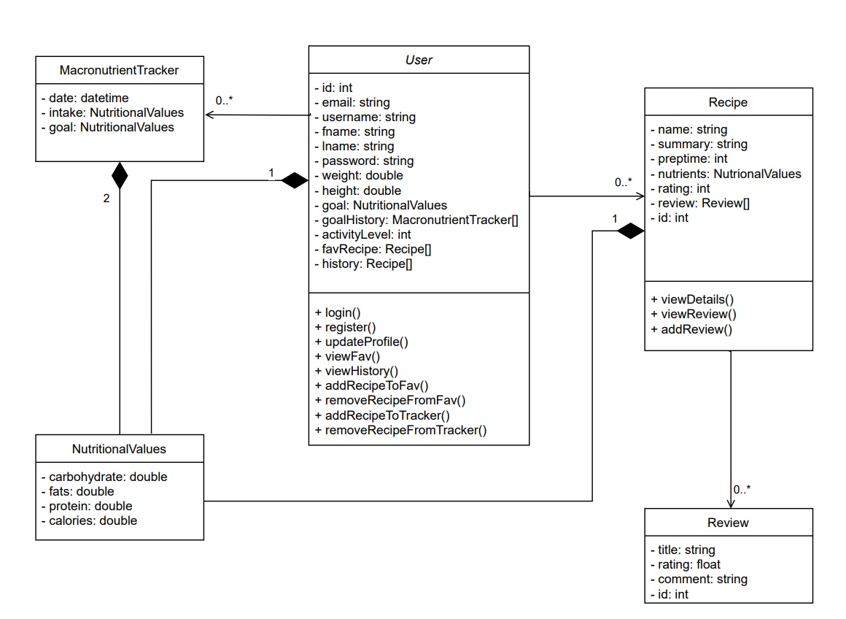

1. Key Boundary Classes and Control Classes

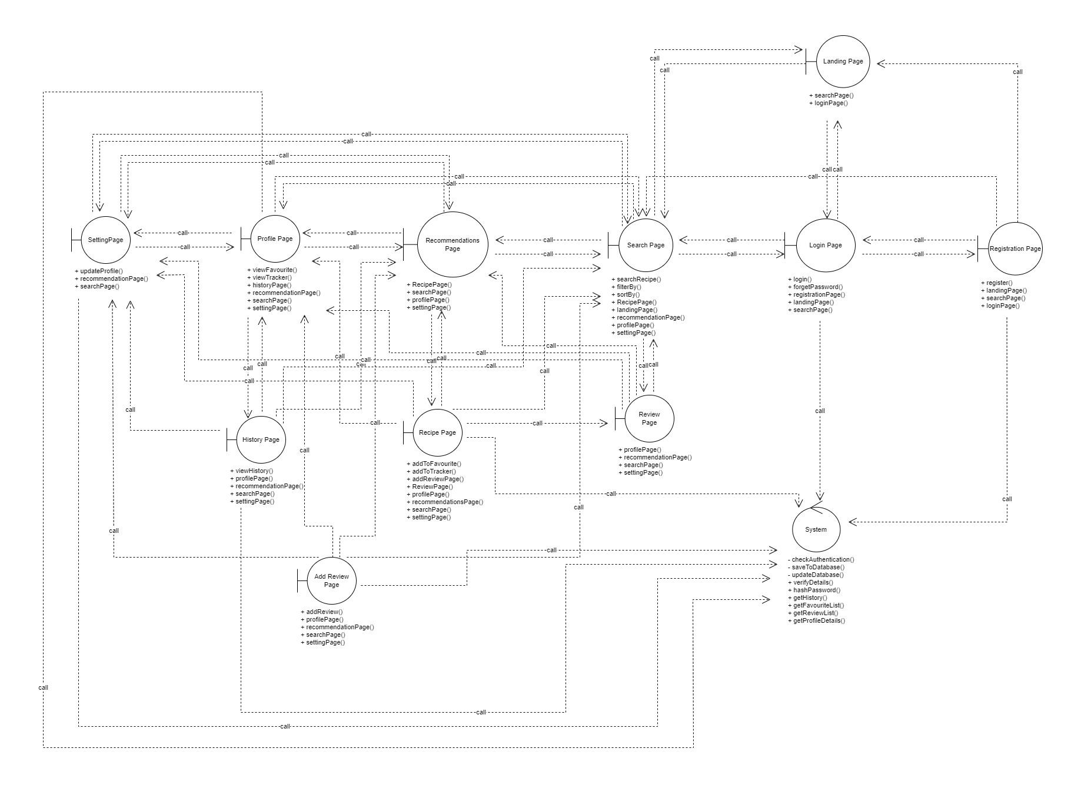

Refer to file in folder for full diagram.

1. Sequence Diagrams
   1. **Daily Intake Tracker**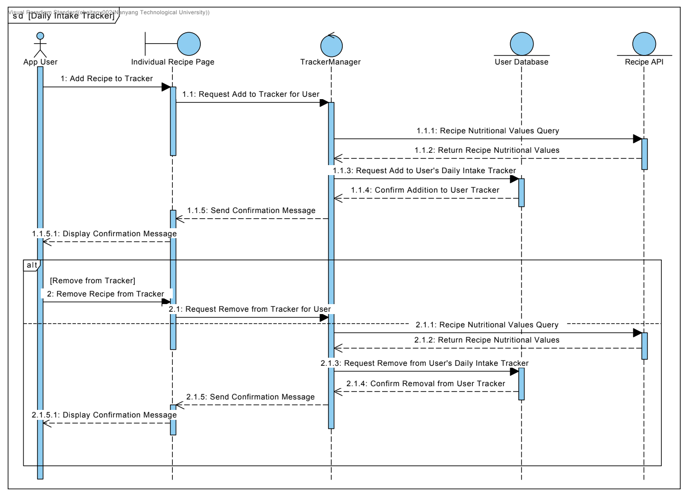
   2. **Individual Recipe Page**

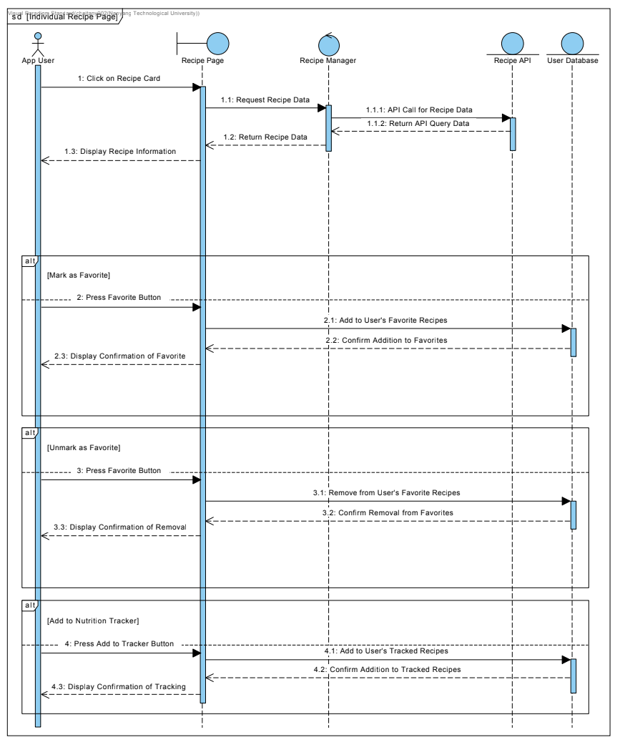

* 1. **Intake Tracker History**

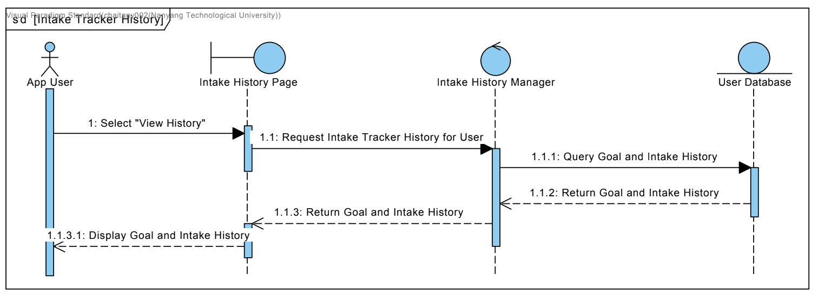

* 1. **Landing Page**

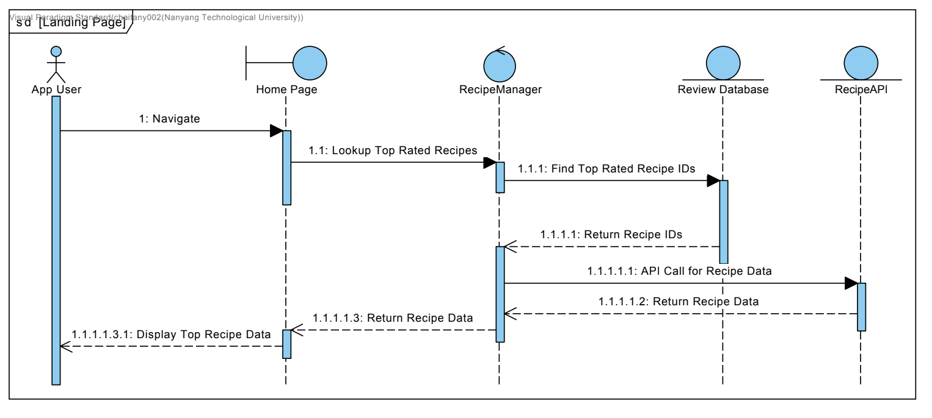

* 1. **Login**

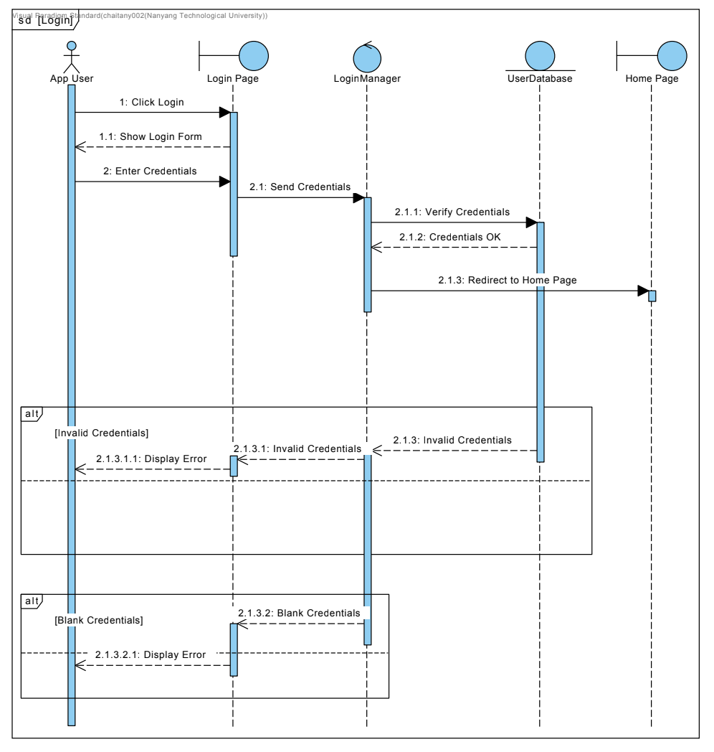

* 1. **Recipe Recommendation View**

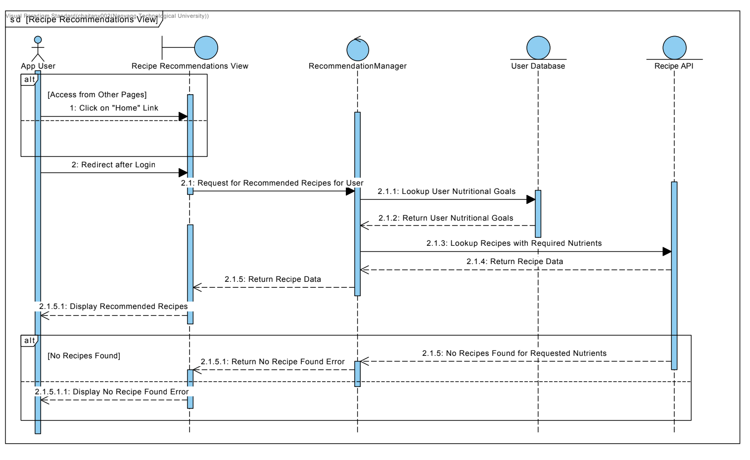

* 1. **Recipe Search**

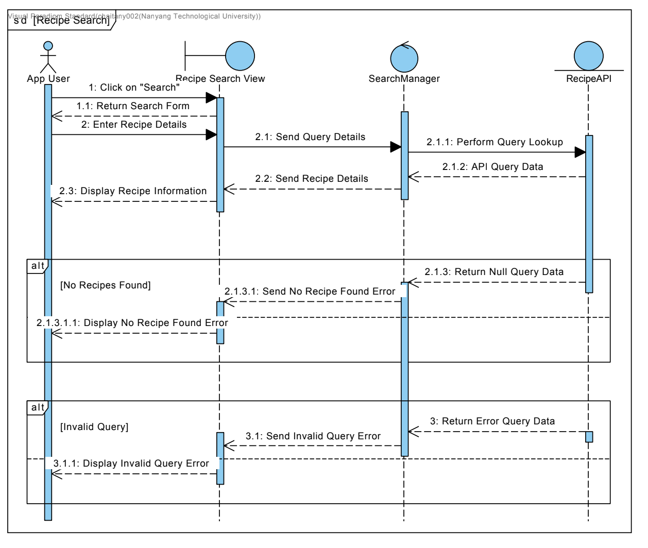

* 1. **Registration**

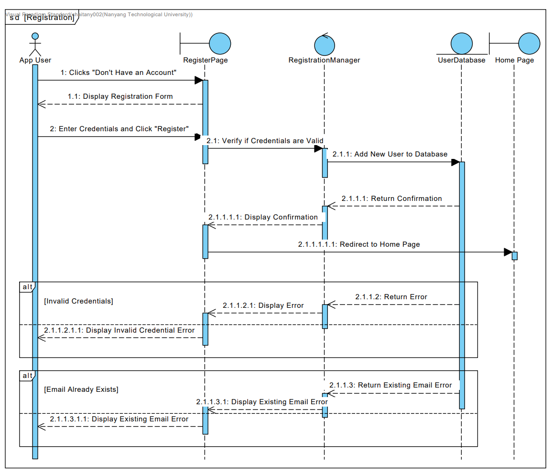

* 1. **Review Recipe**

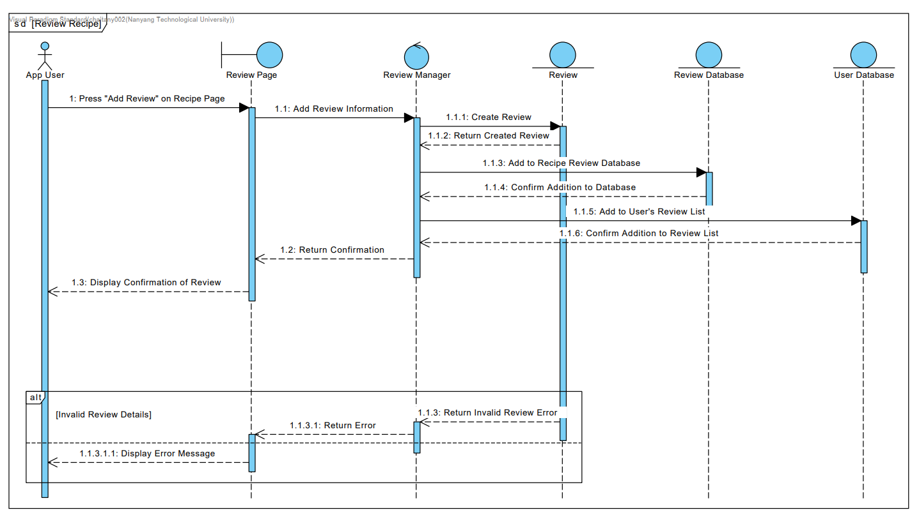

* 1. **Update User Profile**

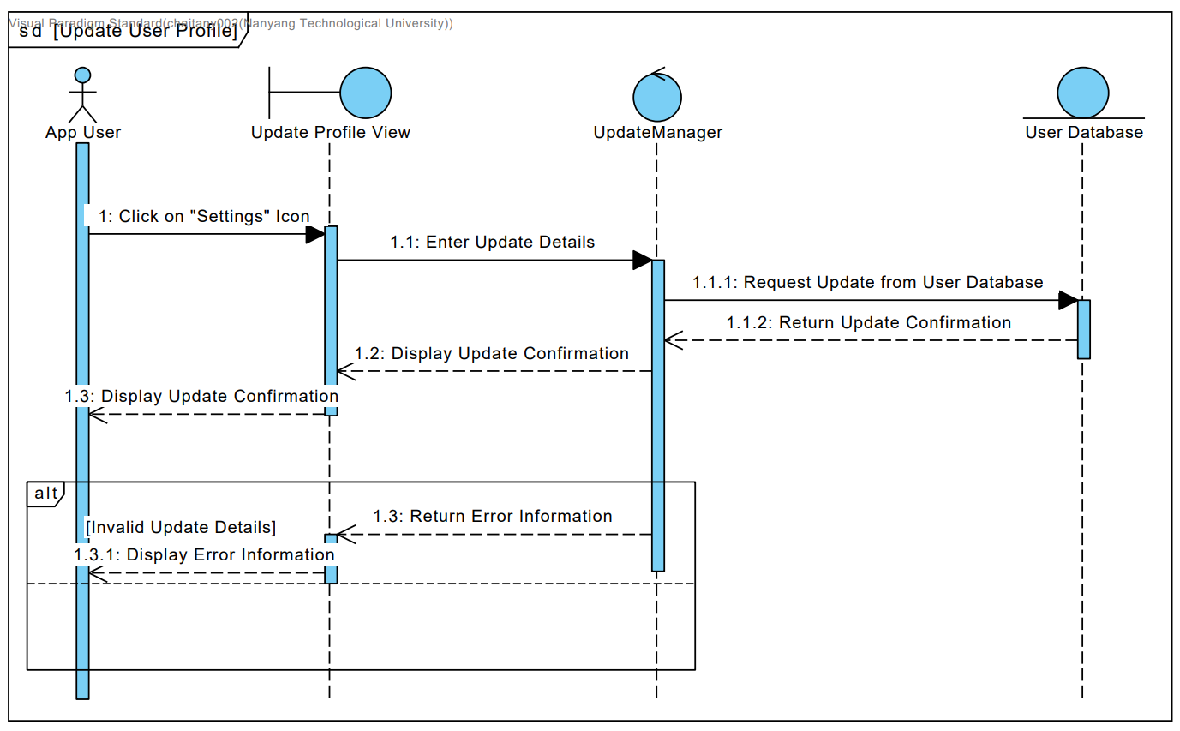

* 1. **User Profile View**

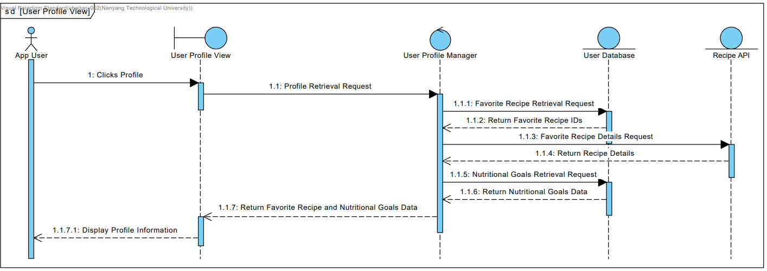

1. Initial Dialog Map



 

 